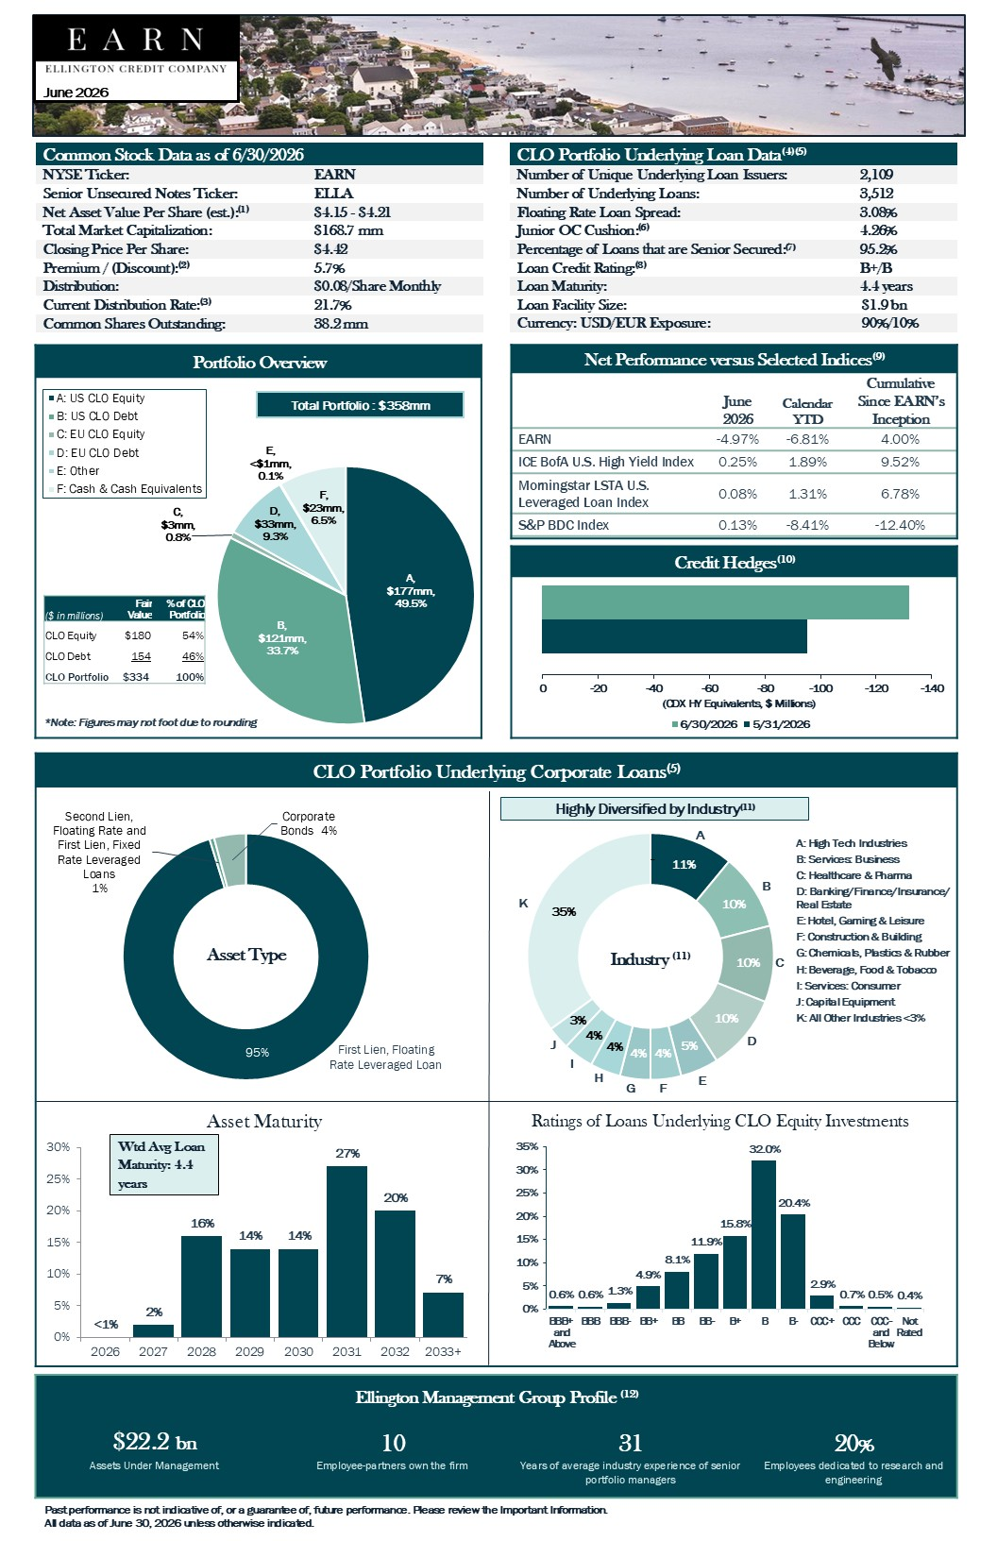
Past performance is not indicative of, or a guarantee of, future performance. Please review the Important Information. All data as of June 30, 2026 unless otherwise indicated. Cumulative Since EARN’s Inception Calendar YTD June 2026 4.00% - 6.81% - 4.97% EARN 9.52% 1.89% 0.25% ICE BofA U.S. High Yield Index 6.78% 1.31% 0.08% Morningstar LSTA U.S. Leveraged Loan Index - 12.40% - 8.41% 0.13% S&P BDC Index Net Performance versus Selected Indices (9) -140 -120 -100 -80 -60 -40 -20 0 (CDX HY Equivalents, $ Millions) 6/30/2026 5/31/2026 <1% 2% 16% 14% 14% 27% 20% 7% 0% 5% 10% 15% 20% 25% 30% 2026 2027 2028 2029 2030 2031 2032 2033+ 95% Second Lien, Floating Rate and First Lien, Fixed Rate Leveraged Loans 1% Corporate Bonds , 4% Asset Type 11% 10% 10% 10% 5% 4% 4% 4% 4% 3% 35% - Industry (11) B C D A E G H I F J K Asset Maturity First Lien, Floating Rate Leveraged Loan A: High Tech Industries B: Services: Business C: Healthcare & Pharma D: Banking/Finance/Insurance/ Real Estate E: Hotel, Gaming & Leisure F: Construction & Building G: Chemicals, Plastics & Rubber H: Beverage , Food & Tobacco I: Services: Consumer J: Capital Equipment K: All Other Industries <3% 0.6% 0.6% 1.3% 4.9% 8.1% 11.9% 15.8% 32.0% 20.4% 2.9% 0.7% 0.5% 0.4% 0% 5% 10% 15% 20% 25% 30% 35% BBB+ and Above BBB BBB- BB+ BB BB- B+ B B- CCC+ CCC CCC- and Below Not Rated Ratings of Loans Underlying CLO Equity Investments A , $177mm, 49.5% B , $121mm, 33.7% C , $3mm , 0.8% D , $33mm, 9.3% E , <$1mm, 0.1% F , $23mm, 6.5% A: US CLO Equity B: US CLO Debt C: EU CLO Equity D: EU CLO Debt E: Other F: Cash & Cash Equivalents Total Portfolio : $358mm % of CLO Portfolio Fair Value ($ in millions) 54% $180 CLO Equity 46% 154 CLO Debt 100% $334 CLO Portfolio *Note: Figures may not foot due to rounding June 2026 Common Stock Data as of 6/30/2026 EARN NYSE Ticker: ELLA Senior Unsecured Notes Ticker: $4.15 - $4.21 Net Asset Value Per Share (est.): (1) $168.7 mm Total Market Capitalization: $4.42 Closing Price Per Share: 5.7% Premium / (Discount): (2) $0.08/Share Monthly Distribution: 21.7% Current Distribution Rate: (3) 38.2 mm Common Shares Outstanding: CLO Portfolio Underlying Loan Data (4)(5) 2,109 Number of Unique Underlying Loan Issuers: 3,512 Number of Underlying Loans: 3.08% Floating Rate Loan Spread: 4.26% Junior OC Cushion: (6) 95.2% Percentage of Loans that are Senior Secured: (7) B+/B Loan Credit Rating: (8) 4.4 years Loan Maturity: $1.9 bn Loan Facility Size: 90%/10% Currency: USD/EUR Exposure: Highly Diversified by Industry (11) Ellington Management Group Profile (12) 20 % 31 10 $22.2 bn Employees dedicated to research and engineering Years of average industry experience of senior portfolio managers Employee - partners own the firm Assets Under Management Wtd Avg Loan Maturity: 4 .4 years Portfolio Overview Credit Hedges (10) CLO Portfolio Underlying Corporate Loans (5)

Past performance is not indicative of, or a guarantee of, future performance. Please review the Important Information. All data as of June 30, 2026 unless otherwise indicated. Notes 1. Estimated net asset value per common share is subject to change upon completion of the Fund’s month - end and quarter - end valuatio n procedures relating to its investment positions, and any such change could be material. There can be no assurance that the Fund’s estimated net asset value per com mon share as of June 30, 2026 is indicative of what the Fund's results are likely to be for the six - month period ending September 30, 2026 or in future periods, and the Fund undert akes no obligation to update or revise its estimated net asset value per common share prior to issuance of financial statements for such periods . 2. Premium/(Discount) is calculated based on the midpoint of the Fund’s estimated net asset value per share as of June 30, 2026. 3. Distribution payments are not guaranteed and may be modified at the board's discretion. They are also sourced from income, ca pit al gains, and return of capital. Return of capital to investors will result in the Fund having less money to invest, which could lower its overall return. 4. The information presented herein is on a look - through basis to the collateralized loan obligation (“CLO”) tranches (both equity and mezzanine) held by the Fund as of June 30, 2026 and reflects the aggregate underlying exposure of the Fund based on the portfolios of those investments. The data is est ima ted and unaudited (and therefore subject to change) and is derived from CLO trustee reports received by the Fund relating to June 30, 2026 and from custody statements an d/o r other information received from CLO collateral managers and other third party sources. Weighted averages shown unless otherwise indicated. 5. Except for Loan Facility Size, all underlying loan statistics include corporate bonds held in our CLO investments . 6. Wtd Avg Junior OC Cushion is calculated solely with respect to positions in CLO equity tranches. 7. Represents the percentage of the total collateral underlying our CLO investments (including both corporate loans and bonds) t hat are characterized as senior secured loans. 8. In calculating weighted average, loan credit ratings used are those assigned by Standard & Poor’s (“S&P”) or, for loans witho ut an S&P rating, the S&P - equivalent rating of another rating agency that does/did rate the loan. 9. Past performance is not indicative of, or a guarantee of, future performance. Total return is calculated based on EARN's clos ing stock price during the applicable period and assuming that any dividends or distributions are reinvested on the applicable payment dates at prices obtained by the Fund's div idend reinvestment plan. Calendar YTD is calculated from January 1, 2026. For the purposes of these figures, EARN's "inception date" is April 1, 2025, which is the da te that EARN completed its conversion to a CLO - focused closed - end fund registered under the 1940 Act. Future results may vary and may be higher or lower than the data shown. A new fund's performance may not represent how the fund is expected to or may perform in the long - term. The indices used herein are presented for illustrative purposes on ly. Indices are unmanaged and are not subject to fees and expenses typically associated with managed accounts or investment funds. Investments cannot be made directly into an in dex. 10. There can be no assurance that instruments in the Credit Hedging Portfolio will be effective portfolio hedges. The Fund manag es the risk of its overall portfolio, including the Credit Hedging Portfolio, through a broader risk management process that includes compliance with a Value - at - Risk (“ VaR ”) limit under Rule 18f - 4 of the Investment Company Act of 1940. VaR is an estimate of potential losses on a portfolio over a specified time horizon and at a given confidence level. For purposes o f Rule 18f - 4, the Fund calculates VaR at a 99% confidence level for a 20 - trading - day horizon using a model calibrated to historical market data to estimate the distri bution of portfolio returns. Under Rule 18f - 4, the VaR of the Fund (expressed as a percentage of the Fund’s net asset value) may not exceed 200% of the VaR of the Fund’s designated reference portfolio (expressed as a percentage of the value of the designated reference portfolio). The Fund’s “designated reference portfolio” is defined as the Fund’s portfolio of securities, cash, and other investments, excluding derivatives transactions. As of June 30, 2026: ( i ) the VaR of the Fund was 29.3%, (ii) the VaR of the designated reference portfolio was 20.7%, and therefore (iii) the Relative VaR Ratio was 141%. VaR is model - based and is only an estimate of potential loss. The estimated VaR of the same portfolio may change over time as new data becomes available and models are updated. Models are inherently imperfect and rely on assumptions that may prove to be inaccurate. As a result, VaR has significant limitations and should be considered accordingly. Corporate credit hedges are shown in notional equivalents of the Markit CDX North America High Yield Index (“CDX HY”). CDX HY eq uivalents are estimated using models calibrated to historical price relationships. Our models change over time, and realized returns may differ from our model pro jec tions. Corporate credit hedges may include CDS, ETFs, equities, total return swaps, and similar instruments referencing both single iss uers and indices, as well as options, tranches, and other derivatives on such instruments. In particular, our credit hedging strategy extensively uses CDX and iTraxx indices, CDX and iTraxx tranches and options, ETFs, and ETF options. 11. Industry classifications are based on Moody’s industry categorization of each obligor as reported in CLO trustee reports, to the extent such information is available. In cases where CLO trustee reports do not provide an industry classification for an underlying obligor, it is included under “All Other Indu str ies”. As a result, the Fund’s actual exposure to certain industries may be higher than what is presented if industry categories were available for all obligors. 12. As of March 31, 2026. The Fund is advised by an affiliate of Ellington Management Group, L.L.C. Important Information Investors should consider Ellington Credit Company’s (the “Fund”) investment objectives, risks, charges and expenses carefull y b efore investing in securities of the Fund. The Fund’s registration statement contains this and other important information about the fund. Investors should read the Fund’s registr ati on statement and Securities and Exchange Commission (“SEC”) filings (which are publicly available on the EDGAR database on the SEC website at www.sec.gov) carefully and consider th eir investment goals, time horizons and risk tolerance before investing in the Fund. Investors should also consider the Fund’s investment objectives, risks, charges and expenses carefully before investing in se cur ities of the Fund. The investment program of the Fund is speculative and entails substantial risk, including the possible loss of principal. There can be no assurance that Fund’s inv est ment objectives will be achieved or that monthly distributions paid by the Fund will be maintained at the targeted level or that distributions will be made at all. The Fund’s di stributions may be funded from unlimited amounts of offering proceeds or borrowings, which may constitute a return of capital and reduce the amount of capital available to the F und for investment. A return of capital to shareholders is a return of a portion of their original investment in the Fund, thereby reducing the tax basis of their investment. An investment in the Fund is not appropriate for all investors and is not intended to be a complete investment program. Share s o f closed - end investment companies, such as the Fund, frequently trade at a discount from their net asset value, which may increase investors’ risk of loss. The Fund cannot predic t w hether its shares will trade at, below or above its net asset value. The Fund may invest primarily in below investment grade instruments, which are commonly referred to as “high yield” securitie s o r “junk” bonds. Investments in below investment grade securities are considered predominantly speculative with respect to the issuer’s capacity to pay interest and repay pri nci pal when due and such issuers are not perceived as strong financially as those with higher credit ratings. The Fund may invest a significant portion of its assets in CLO equity and me zza nine debt securities, which often involve risks that are different from or more acute than risks associated with other types of credit instruments. Past performance is not indicative of, or a guarantee of, future performance. The performance and certain other portfolio information quoted herein represents information as of dates noted herein. Nothing herein shall b e r elied upon as a representation as to the future performance or portfolio holdings of the Fund. Investment return and principal value of an investment will fluctuate, and sha res , when sold, may be worth more or less than their original cost. The Fund’s performance is subject to change since the end of the period noted in this report and may be lower or higher than the performance data shown herein. The information in this communication is not complete and may be changed. The Fund may not sell any securities until it has f ile d a registration statement with the SEC that seeks to register securities and has been made effective by the SEC. The information and its contents are the property of the Fund, is provided for general and educational purposes only, and is not intended to provide legal, tax or investment advice. Further, this information does not constitute a solicitation of an offer to buy or sell shares of the Fund, and is not for us e t o avoid penalties that may be imposed under U.S. federal tax laws. You should contact your own advisor regarding your specific legal, investment and tax decisions. Any unauthorized diss emi nation, copying or use of this presentation is strictly prohibited and may be in violation of law. About Ellington Credit Company Ellington Credit Company (the "Fund") is a non - diversified closed - end fund that seeks to provide attractive current yields and r isk - adjusted total returns by investing primarily in corporate collateralized loan obligations ("CLOs"), with a focus on mezzanine debt and equity tranches. The Fund is externall y m anaged and advised by an affiliate of Ellington Management Group, L.L.C., a leading fixed - income investment manager founded in 1994. The Fund benefits from Ellington’s extensiv e experience and deep expertise in portfolio management, credit analysis, and risk management. For additional information, visit http://www.ellingtoncredit.com .

